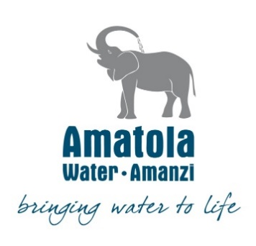
NOTICE TO ALL BIDDERS

CANCELLATION OF RFQ

Amatola Water Board hereby notifies the Public that the following RFQ have been cancelled.

RFQ / Bid Number | RFQ Description
RFQ – 104-24/25 | REMOVAL, HANDLING, TRANSPORT & STORAGE OF PIPE WORK, VALVES, FILTTINGS AND ANCILLARY COMPONENTS AT BINFIELD WTW.

Enquiries: - Ms T. Mampe
SCM Official: E-mail address: tmampe@amatolawater.co.za

